Data-6200 Final Project Report

Evan Switzer

NHL Draft Picks:

How Much Better is the 1st Overall Pick?



Contents

Summary 2

Introduction 2

Data 2

Key Findings 3

Design Elements 4

Images **Error! Bookmark not defined.**

# Summary

This dashboard found that the 1st overall draft pick is obviously the best draft pick, not only because it results in the best player, but because it yields the most consistent results. Every round is possible to produce an NHL caliber player, but the later you get into the draft the worse the chance is. Even though the 1st overall draft pick is the best, it does not guarantee your team will be good.

# Introduction

This dashboard will look at NHL draft and NHL season data. It aims to find if a 1st overall draft pick is that much better than the rest and by how much.

The NHL (National Hockey League) is the top league to play in for professional hockey. Every year there is a draft during the summer. A draft is when young players, around 17-18, are selected by a team to play for them for their first couple years in the NHL. After those couple years they can choose to stay or leave, and most usually stay unless the team treated them very poorly. Drafting 1st overall is considered very strong by the general community but it is only possible if your team does exceptionally poor the year before. It is in this way that the draft is a catchup mechanism for teams that are struggling.

# Data

The data I used is from multiple NHL endpoints that they use for their site. They allow anyone to use it but have no documentation on them. This caused me to have to work a little too hard to find the information. Here are some examples of API calls I made:

* <https://records.nhl.com/site/api/draft?start=0&limit=100&cayenneExp=draftYear=1971>
* <https://api.nhle.com/stats/rest/en/skater/summary?cayenneExp=playerId=8450308>
* <https://api-web.nhle.com/v1/club-schedule-season/BUF/19751976>
* <https://api-web.nhle.com/v1/gamecenter/GAME-ID/play-by-play>

As you can see there are multiple different APIs with multiple different endpoints, each taking a little bit of time to request. To get this data it would take multiple hours of running to just query the data. I did not need all this data, but I was not able to figure out if I could request only certain details.

Once I had the data from one API, I would take the necessary information I needed and use that for the next API. I would merge some information to data frames. Once I had all this information, I saved it so I wouldn’t have to get the information again, and then used it to create my dashboard.

A couple indicators I created from the data were points per player (total points/number of players) and points per game (total points/number of games played).

I also gathered goal location data from the APIs. This required me getting each player, finding the teams that the player played on, looking up each game that the team played while the player was on it, getting all events of those games, filtering those events down to goals for that specific game, and finally filtering those goals down to 1st overall picks and getting the location of the goals.

# Key Findings

The key finding I found was that the first overall pick had a much higher goals, assists, points, and games played per player. This can be seen in the “Draft Year vs Average of Goals per Player” graph. There is such a large distance between the 1st overall pick and the rest of the draft picks that I had to apply a log function to the scale.

Draft Year vs Average of Goals per Player

During my presentation of my dashboard there was a question about instead of doing it per player, I could do it per game played. This was an excellent question that I had not investigated enough. I went with per player as I wanted to include players that didn’t play any games. If the points per game is considered and graphed the below graph “Draft Year vs Points Per Game of Player” is the result. This graph shows that it is much closer of a competition between the 1st overall draft pick and the rest of the draft. The 1st round, 2nd round and 3rd round all have spikes where they go close to or above the 1st overall draft pick. However, I don’t believe this shows an accurate representation of how valuable each draft pick is.

Draft Year vs Points Per Game of Player

I went to investigate a little further. I decided to take one of the more surprising points on the graph. In 2007 the 7th round draft picks had a points per game of 0.774. Below are two graphs, the left one is points of all players drafted in the 7th round in 2007, and the right is the games played of each of those players. As you can see only 4 players recorded points from the 7th round. Looking at points per game instead of points per player lets outliers have a huge impact on how that draft round looks. As 7th round picks aren’t expected to make the NHL these aren’t duds but finding an NHL player in the 7th round is just extreme luck, which makes the 7th round draft picks not valuable even though sometimes they may have a points per game of 0.774. I chose points per player to account for these outliers, and to show the value of the pick, not how well the handful of players that made it to the NHL did.

# Design Elements

I made my dashboard as simple as possible while still providing plenty of information. I included a sidebar for navigation to each section and to provide bits of information to help anyone who was not familiar with hockey and the NHL. The first graphic I included was a table. This was to start off simple with a nice way to compare 1st overall draft picks throughout the years. I included all the simple stats (goals, assists, points, games played) along with things like the height and weight they were when drafted, the team they were drafted by, and their position. Users could easily go through this and find outliers which would then be allowed to investigate further below.

The next graphic was a scatterplot of goals superimposed on a map of half of a hockey rink. With the goal location I was able to plot all the goals of each 1st overall draft pick. I wanted this to show how each player played slightly differently so I added a dropdown menu to select the player you wanted to see. You could see if a player liked to play close to the net so all their goals would be up close, or if they played defense more of their goals would be further away from the net. I added a little blurb off to the side to explain what the scatterplot was showing as it could be confusing to someone who is looking at it for the first time.

The final graphic is a line graph of how each round did throughout the years. Above the graph are buttons to select which performance indicator you wanted to look at (goals, assists, points, games played). The 1st overall lines were too high compared to the rest, so I adjusted the scale and talked about above. I also added the ability to select certain lines to hide or show. This lets the user compare specific rounds without all the clutter.

# Screenshots of Dashboard

Full Dashboard

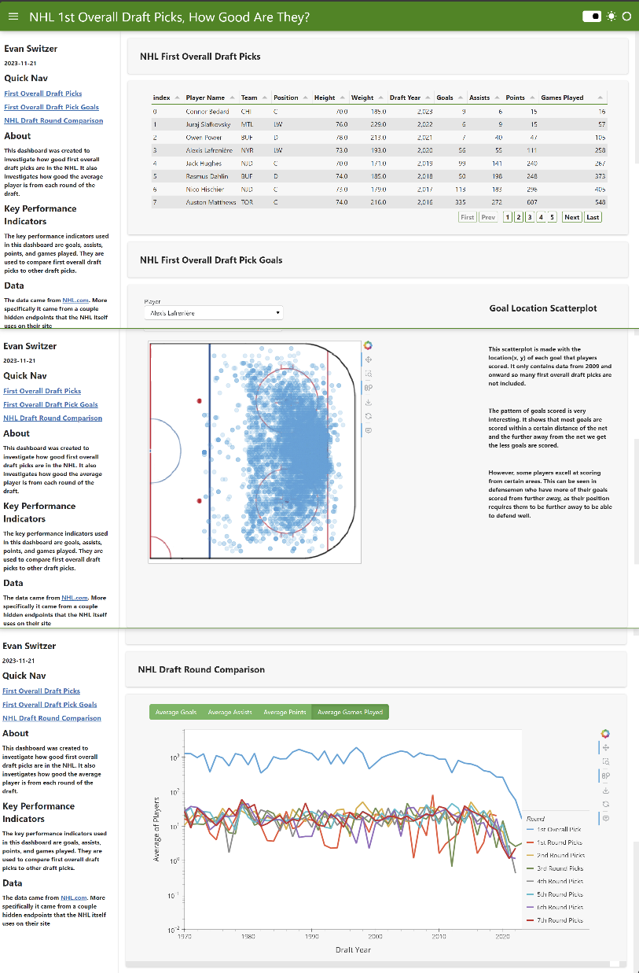

NHL First Overall Draft Picks

If needed I can provide the python code for the data aggregation and dashboard. I can also find a way to host it online if needed. If so please let me know switzere@uoguelph.ca.